# MICRO PYTHON

MicroPython is a lean and efficient implementation of the Python 3 programming language, designed to run on microcontrollers and other small embedded systems, allowing developers to write Python code directly on these devices

**Elements**

**Micro controller:**

A microcontroller is a small, self-contained computer on a single integrated circuit (IC) chip, designed to control specific tasks within an embedded system, often containing a processor, memory, and input/output peripherals.

|  |  |  |  |
| --- | --- | --- | --- |
| Controller name | coding language | price | usage |
| ESP32 | c++/micro python | 400 | 30 pin,wifi,bluetooth |
| pico 2 w | c++/micro python | 600 | integrated wifi, bluetooth, 30 pins, 520KB |
| pi zero 2 w | micro python | 1500 | integrated wifi, bluetooth, 40 pins,usb-otg, camera connector,mini hdmi, sd card,512MB |
| raspbery pi 5 | micro python | 8000 | 2usb,2usb3,ethernet,2micro hdmi, usb-c power,camera port,audio port,POE ethernet, disply interface, 8GB RAM |
| other micro major controllers | | | |
| Arduino uno | c++ | 200 | 28 pins |
| Arduino nano | c++ | 200 | 30 pins |
| nodemcu | LUA/micro python | 250 | wifi |
| ARM |  |  |  |

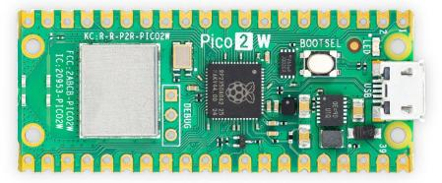**Pico 2 w...........**

**Power source:**

* usb powered :Voltage: 5V regulated (on-board regulator drops it to 3.3V for the chip).
* VSYS Pin (1): Supply 3.6V to 5.5V to the VSYS pin

**Current (A): DC**

**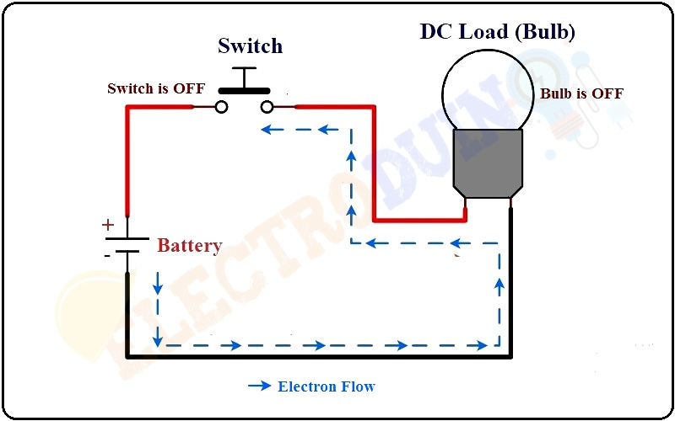**Direct current (DC) is one-directional flow of electric charge

To ensure the voltage of current we can use Regulators.

**Types of power suppy:**

AC-DC adopters

batteries

**power supply selection:**

1.choose battery only if movable/portable product required

example: toy car, drone,remote controller.

2. choose DC adopters if movable/portable are not required.

**voltage selection:**

choose voltage of battery or adopter if the parts required more torque or speed.

if motor included in the product and the motor used for blower or to move the product with load, we have to choose more than 5v. like (6v,9v,12v). 12v will be the better option for future update if you are using more than 5v. so, better choose 5v and 12v. inbetween voltages we can reduce it by buck convertor/ voltage regulators.

**batteries:**

* ❌ **lead acid batteries**: low price, size and weight high, higher current, to be charger in correct intervals

12v~650rs, 6v~400rs, 4v~100rs

* ✅**Lithium batteries:** light weight, charge any time, bms required, low self discharge, need dedicated charger

LI-ion: 3.7v (3500 mah) ~100rs,

LIFePo4: 3.2v (6000 mah) ~200rs, more life, less heat

NiMH: 1.2V

LI-Po: 3.7 v

|  |  |  |  |  |  |  |
| --- | --- | --- | --- | --- | --- | --- |
| brand | model | mah(max per cell) | seller | price | discharge | total x4 |
| ornage | IFR32650 | 6000 | robu | 471 | 3c | 1884 |
| HX | IFR32700 | 6000 | quertz components | 206 | 3c | 824 |

(A grade/EV grade) is high quality

**power setup:**

* 5v power source - power bank (10000 mah 2A ~ 500 rs)
* 12v power source - not readily available. have to build diy from battery,bms charging module and output regulator.

if you want compact choose Li-Ion (7000mah,7v setup~2000,12v setup~3000)

if you want long lasting choose LiFePo4 (6000mah,7v setup~1000,12v setup~2000)

**battery arrangement:**

series arrangement - will increase voltage (V)

parellel arrangement -will increase current (A)

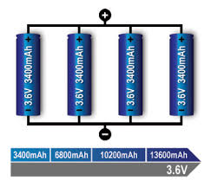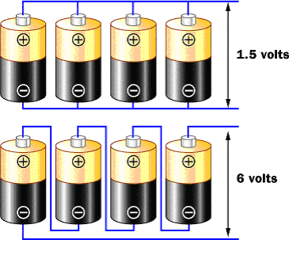

**battery management system (BMS):**

BMS helps to manage input and output voltage for protect from overcharging and over heating. also helps to arrange the batteries in parellel to uniform draw. based on the battery arrangement and battery type different model bms are available.

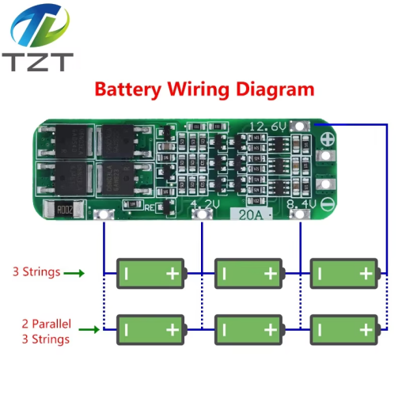[1,200 × 1,200](https://www.google.com/url?sa=i&url=https://www.ktron.in/product/4s-10a-bms-for-lithium-ion-battery/&psig=AOvVaw39ISglsd4bfzN-jEmZPzzB&ust=1744813776651000&source=images&cd=vfe&opi=89978449&ved=0CBQQjRxqFwoTCKDEof6f2owDFQAAAAAdAAAAABBQ" \t "/Users/viswanathanl/Desktop/x/_blank)

**battery charger:**

**Voltage regulators:**

A voltage regulator is an electronic component or circuit that provides a constant output voltage regardless of changes in the input voltage or the load

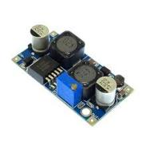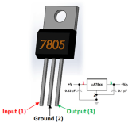



D

models:buck/boost convertor,Linear Regulators

stepdown is always efficient

buck convertor is best:

2A , adjustable voltage (LM2596 ~45rs)

2A, adjustable with display (LM2596~100rs)

3A, adjustable with display(~130rs)

5A, adjustable with display(~250rs)

**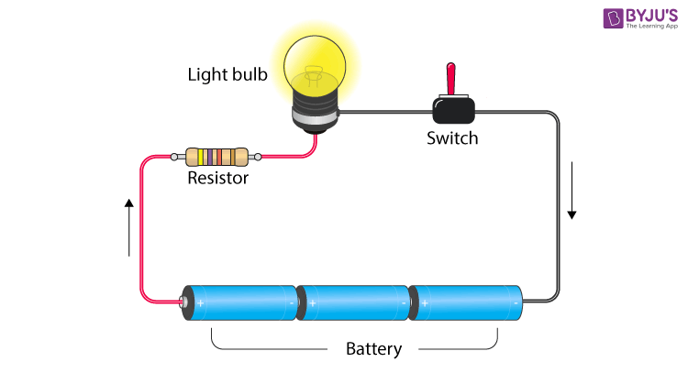Resistor:**

A resistor limits or controls the flow of electrical current in a circuit.

different resistors are available based on value of resistance.

LEDs are current-driven, not voltage-driven. If you just connect one directly to a power source (like 5V), it will draw too much current, heat up, and burn out very quickly.

| LED Color | Forward Voltage (Vf) |
| --- | --- |
| Red | 1.8V – 2.2V |
| Green | 2.0V – 3.0V |
| Blue | 3.0V – 3.5V |
| White | 3.0V – 3.5V |
| Yellow/Orange | 2.0V – 2.2V |

The voltage across an LED depends on its color, because different materials are used for each:

Resistor = (Supply Voltage - LED Voltage) / Desired Current

= (5V - 2V) / 0.02A

= 150 ohms

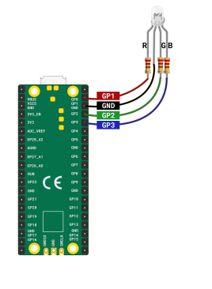**LED:**

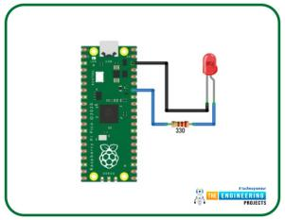An LED is a special kind of electronic component that lights up when current flows through it in the correct direction.

Long leg (anode) → connect to positive

Short leg (cathode) → connect to ground

types:

single color LED

RGB LED

IR LED

LED strip(addressable)

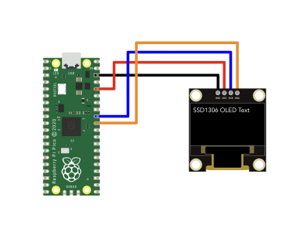LED strip (non addressable)

displays:

16x2 LCD

OLED

7 segment

**Motor:**

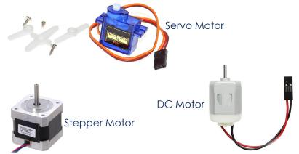A motor is a device that converts electrical energy into mechanical motion—basically, it spins when you give it power!

types:

* + AC motor
  + DC motor
  + Stepper motor
  + Servo motor

motors are available in various voltage based on speed and torque

if the motor voltage is 3.3 v or 5 v. we can dorectly connect it with micro controllers to test it. but it is not safe to connect directly with micro controller. because of voltage drop, back emf, etc,. to avoid this issues and optain other features, some of the electronic elements needs to be added.

**Hbridge combination of transistors:**

H bridge is used to control the motor direction and current

**Transistor:**

A transistor is a miniature semiconductor that regulates or controls current or voltage flow

types:Bipolar junction transistor (BJT)-NPN or PNP

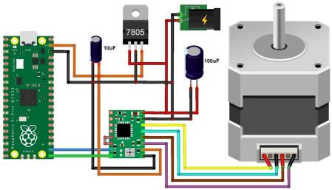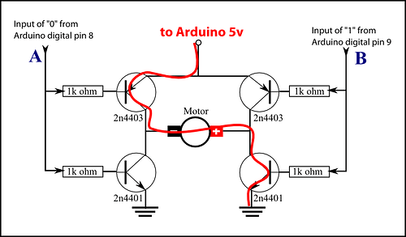

**Capacitors:**

To store energy and enable smooth start and stop. normally used in motors to reduce noice

**motor drivers:**

combination of elements readily available in market to enable motor features

L298N,MX1508,TA6586

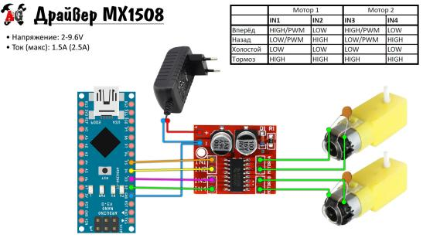

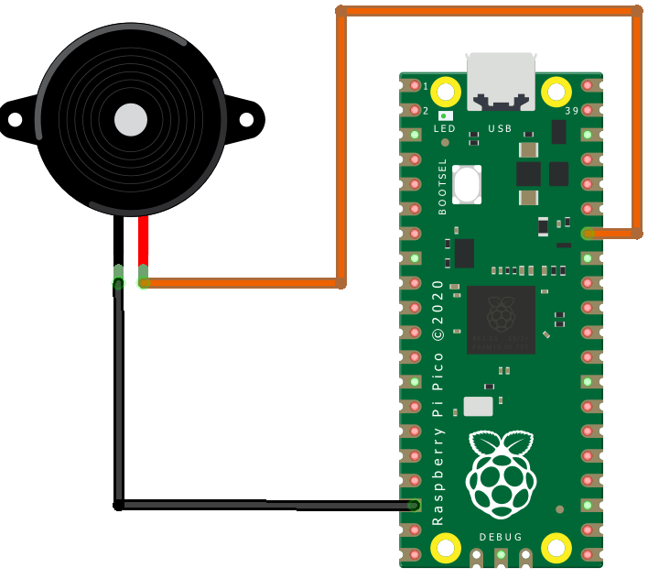

**Buzzer:**

To produce tone note in micro contoller

**Signal receivers:**

**WIFI:** pico have inbult WIFI module to handle wifi signals, also it produce access point for wifi connection

**Bluetooth:** similar to WIFI pico have bluetooth also to send and receive bluetooth signals

**IR Receiver:** Infra Red receivers will receive signals from IR LED or IR Transmitter module,

after receiving the signals as pulse rate, it will be decoded or raw pulse data handled by pico.

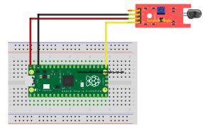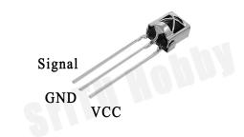

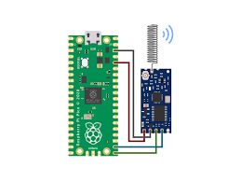

**RF Receiver:**

An RF receiver in the context of a Raspberry Pi Pico is a module that allows the Pico to receive wireless signals over radio frequency (RF) — usually for remote control applications like controlling lights, motors, or robots wirelessly.

**Signal Transmitter:**

similar to receivers the male components also available to produce signals.

wifi/bluetooth(inbuilt) , IR transmitter, RF transmitter

**Sensors:**

**Proximity sensor**

### ****For Short-Range Object Detection (2-30 cm)****

#### IMG_256 ****IR Proximity Sensor (e.g., Sharp GP2Y0A21YK0F)****

**Type**: Infrared analog

**Range**: ~10 to 80 cm (varies by model)

**Pros**: Cheap, simple to use

**Cons**: Sensitive to ambient light, not super accurate

#### ****TCRT5000 Reflective IR Sensor****

**Type**: Infrared digital

**Range**: 0.2-2 cm (good for line-following, edge detection)

**Pros**: Super cheap, works well on short-range surfaces

**Cons**: Extremely short range, surface-dependent

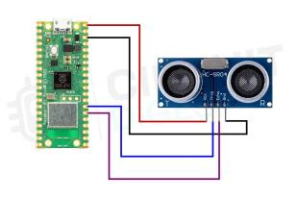

### ****For Mid-Range Distance Sensing (2 cm -4 m)****

#### ****HC-SR04 Ultrasonic Sensor****

#### ****Type****: Ultrasonic (digital)

**Range**: 2-400 cm

**Pros**: Inexpensive, reliable, works in the dark

**Cons**: Needs 5V (Pico is 3.3V, so use a level shifter or resistors)

**Libraries**: Well-supported with MicroPython & C/C++

#### ****RCWL-0516 Microwave Radar Sensor****

#### ****Type****: Microwave Doppler radar

#### ****Range****: ~5-7 meters

#### ****Pros****: Works through thin objects (like plastic), not affected by light

#### ****Cons****: Less precise; more of a motion detector

### ****For High Precision/Multiple Features****

#### IMG_256 ****VL53L0X / VL53L1X Time-of-Flight (ToF) Laser Sensor****

#### ****Type****: Laser ranging (I2C)

**Range**: Up to 2m (L0X) / 4m (L1X)

**Pros**: Very accurate, small, not affected by light or color

**Cons**: Slightly more expensive (~$5鈥15)

### ****Top Recommendations by Use Case****

| **Use Case** | **Best Sensor** |
| --- | --- |
| Basic object detection (<30cm) | TCRT5000 / IR sensor |
| Obstacle avoidance (robots) | HC-SR04 / VL53L0X |
| Accurate distance measurement | VL53L0X / VL53L1X |
| Human presence detection | RCWL-0516 |

**Temperature sensor:**

Pico having inbuilt Temperature sensor, if we want to check temperature of specific place we can add external sensors.

based on the usage location We have different types of thermal sensors

coil sensor, Air humidity sensor,...

**Light sensor:**

A light sensor is an electronic component that detects the amount of light in the environment and converts it into a signal (usually voltage) that a microcontroller like the Raspberry Pi Pico can read.

**Sound sensor:**

A sound sensor is an electronic device that detects sound vibrations (usually in the form of air pressure waves) and converts them into electrical signals that a microcontroller—like the Raspberry Pi Pico—can read.

**Motion sensor:**